IOE324 Introduction to DevOps and Microservices
Assignment-3

2022BCD0008
A.Hemanth Sai Manikanta

You are required to containerize and deploy a full-stack web application using Minikube. The application should consist of a backend API (Flask) that interacts with a database of your preference ( MySQL). Your task is to:
- Develop a simple web API that supports basic CRUD operations and connects to a database.
- Write a Dockerfile for your backend application and name the image as your RegisterNumber-Name (e.g., 2022bcd0008 – hemanth).
- Set up Kubernetes components for deployment:
  - Create a Deployment for your backend and name it as backend-deploy-RegisterNumber.
  - Use a ConfigMap to store database connection details and name it db-config-RegisterNumber.
  - Use Secrets for storing sensitive database credentials.
  - Create a PersistentVolume and PersistentVolumeClaim (if required for the database).
  - Expose the backend using a Kubernetes Service and name it backend-service-RegisterNumber.
- Deploy everything in Minikube, ensuring that your application runs successfully.
- Once deployed, test your API using curl, and provide a screenshot of your running application and Kubernetes components.

app.py

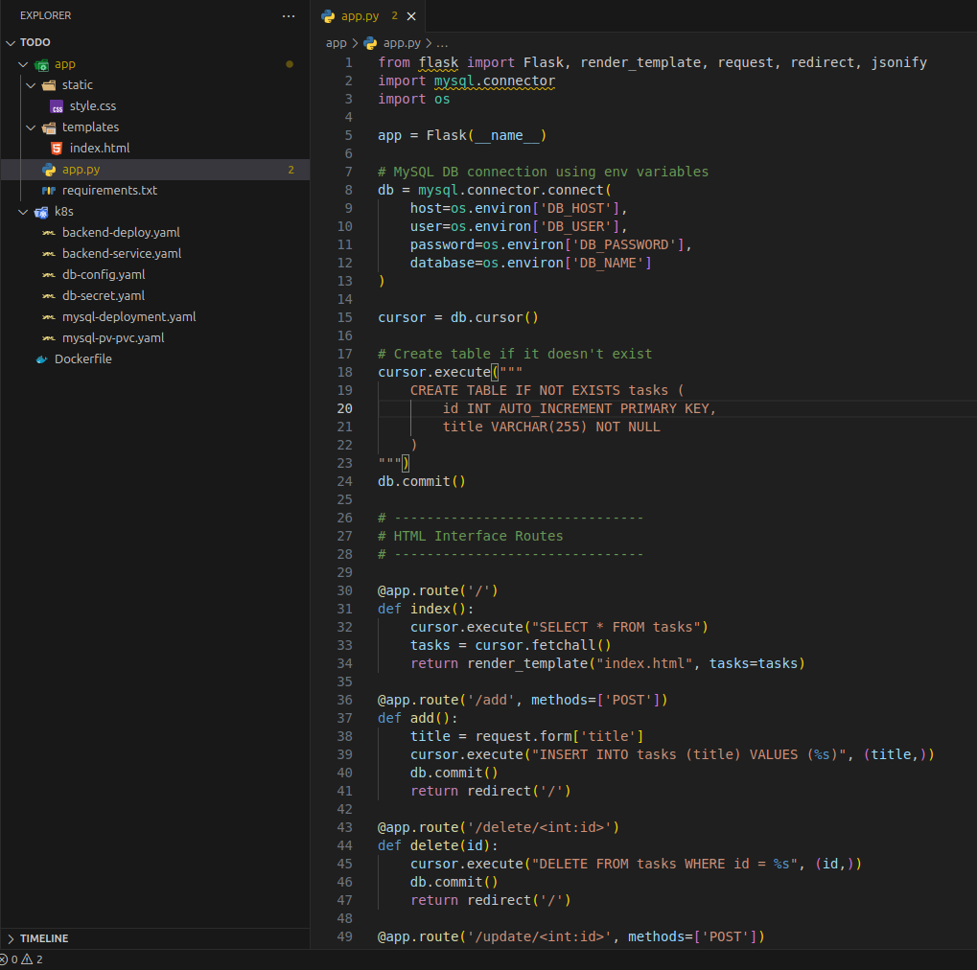
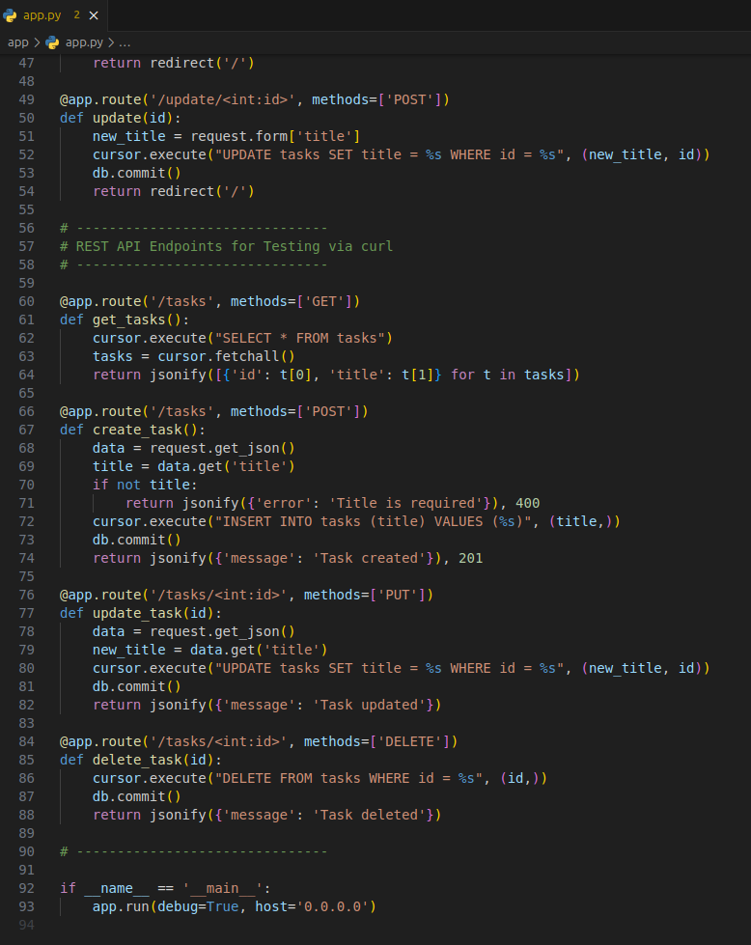

requirements.txt
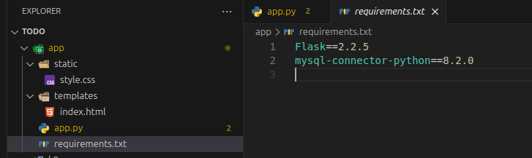
Dockerfile
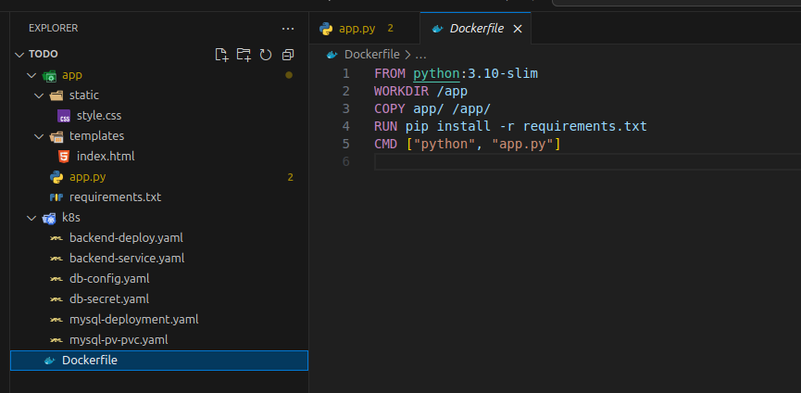
Kubernetes Configs :

🔹 ConfigMap – > db-config.yaml
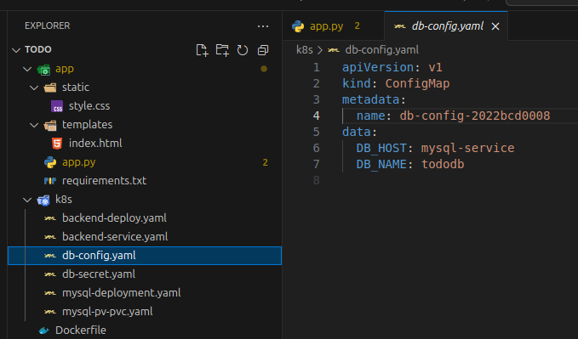

🔹 Secret – db-secret.yaml

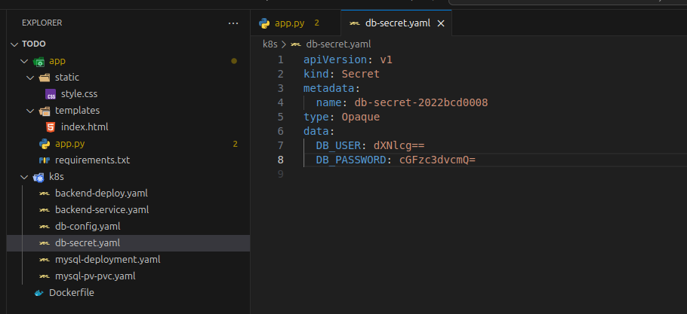

🔹 Backend Service – backend-service.yaml.

Expose the backend using a Kubernetes Service and name it backend-service-2022bcd0008

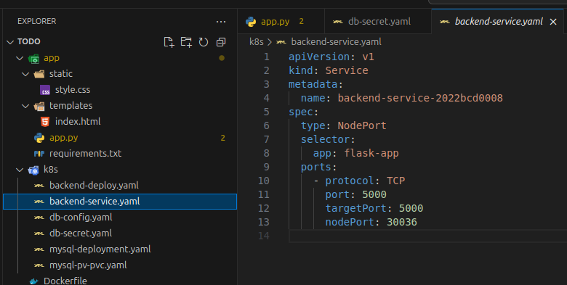

🔹 Backend Deployment – backend-deployment.yaml
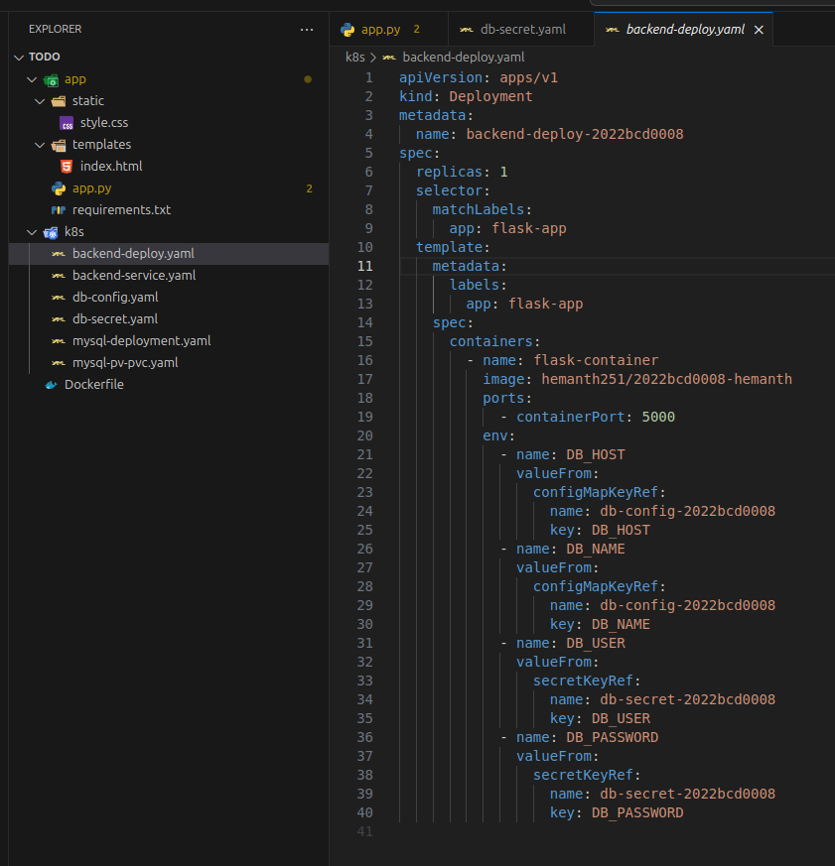

MySQL Setup

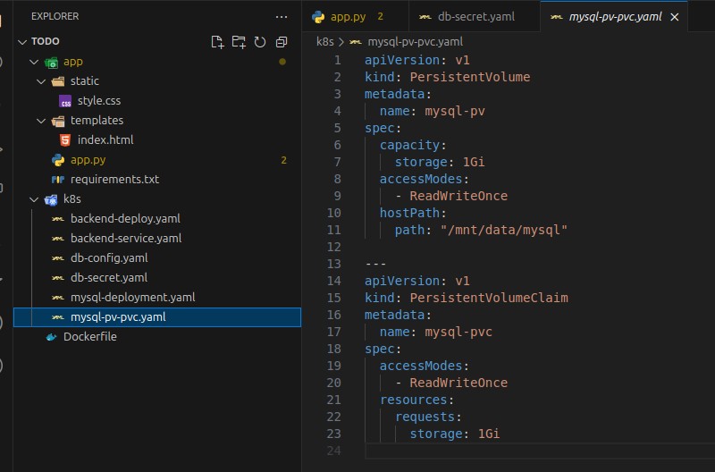
🔹 MySQL Deployment – mysql-deployment.yaml

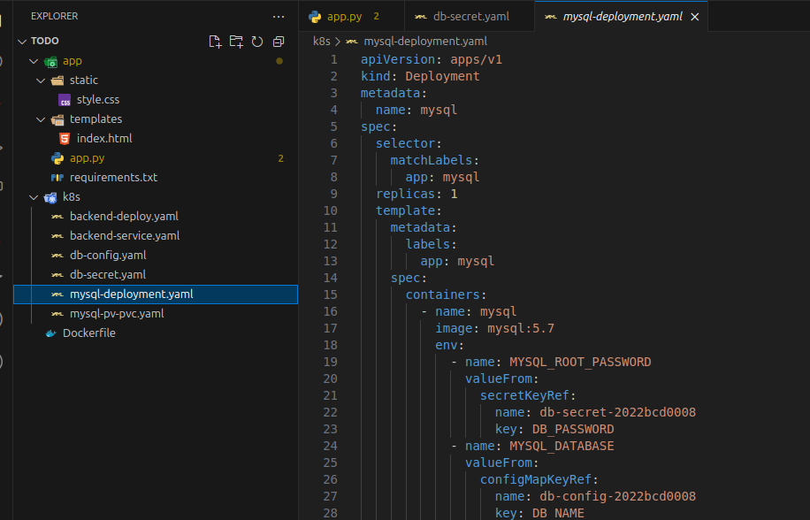

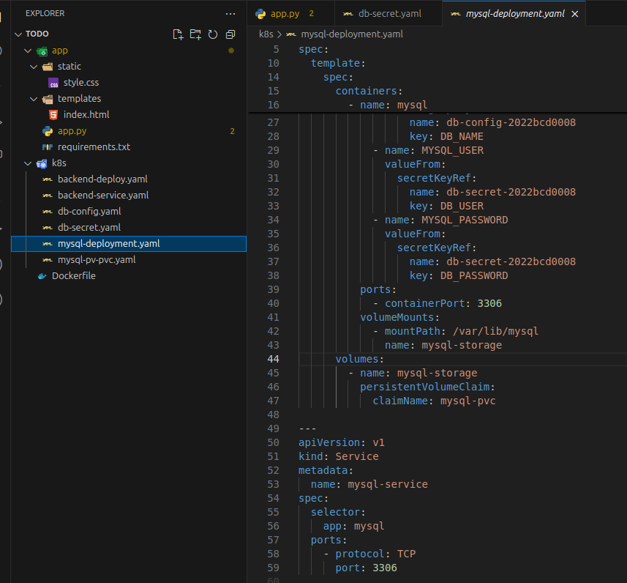
Deployment Steps : 1. Start Minikube

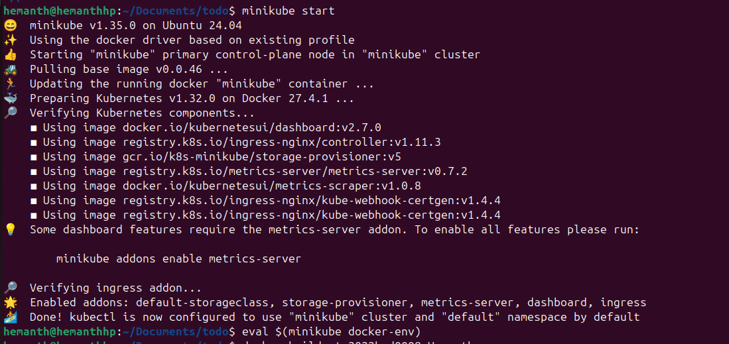
Docker build
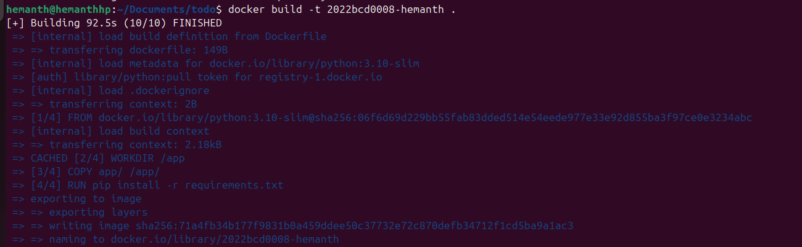
Apply all YAML files:

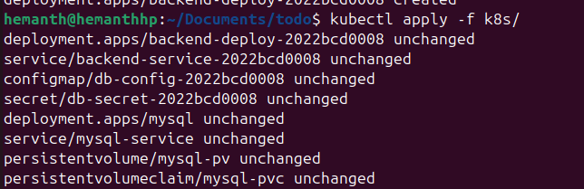
Docker build and pushing

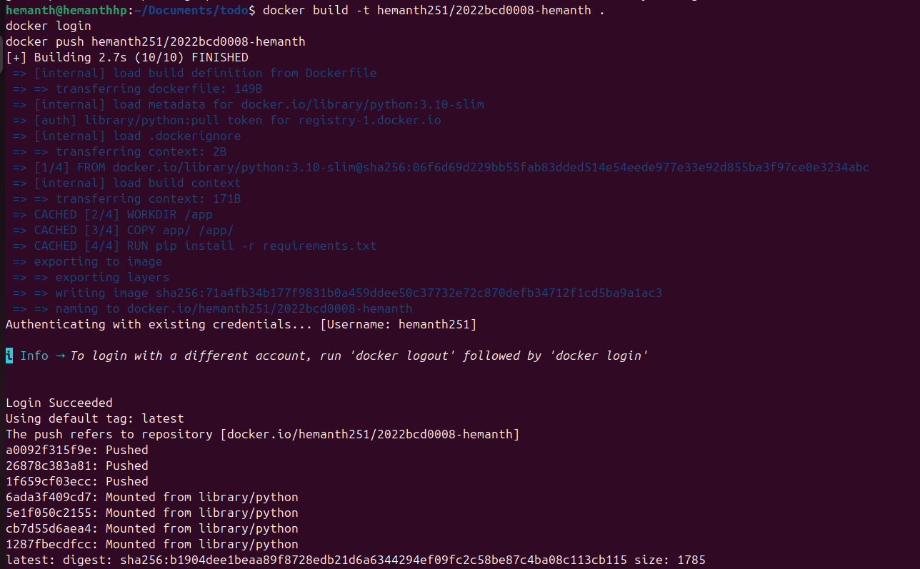

Check pods & services:

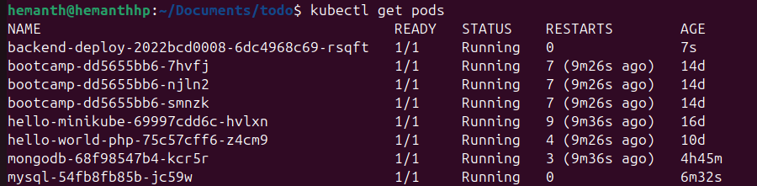
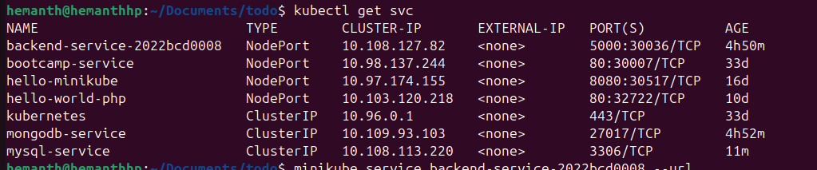
Accessing Web App:
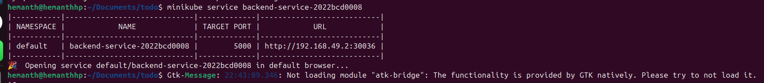
User Interface
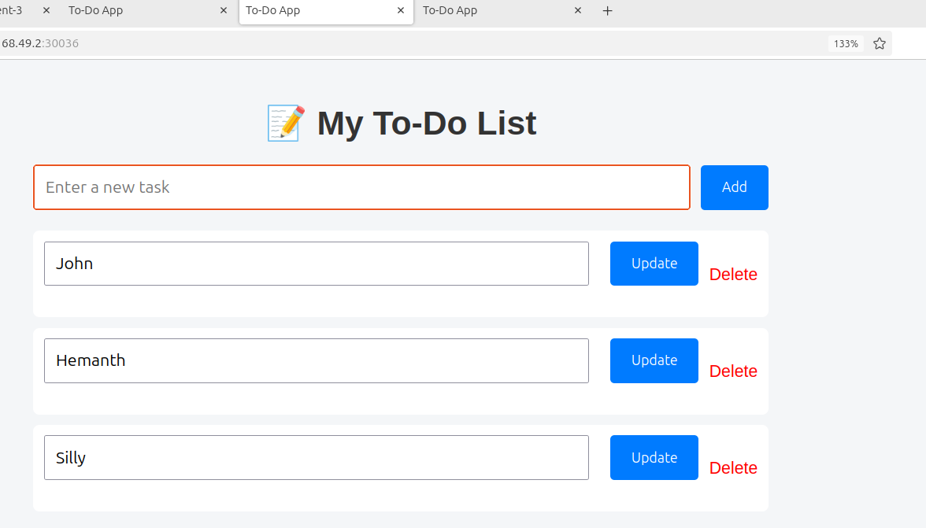

Providing github link Here https://github.com/aHemanth123/Todo_flask_mysql_docker_kuberenetes_frontend

Acessing Url:
Test your API using curl ,

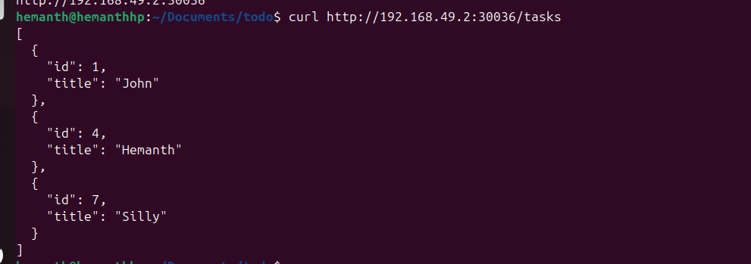
----------------------------------------------------------------------
Adding the data – NewTaskFromCurl

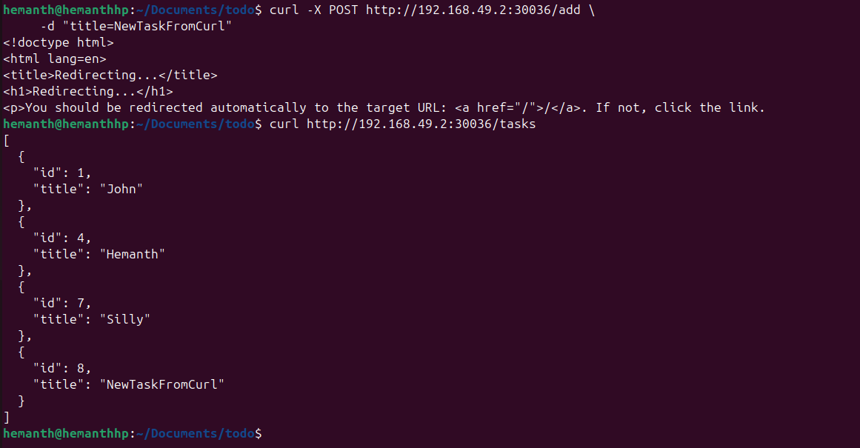

Data at backend :

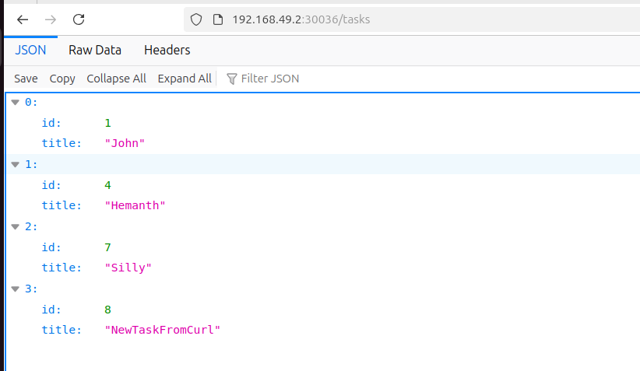
-------------------------------------------------------------------------
Update Operation:

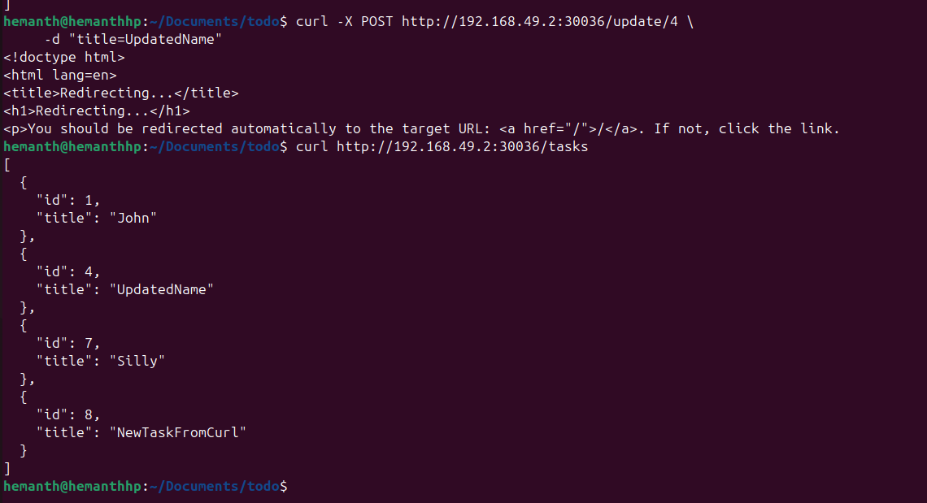

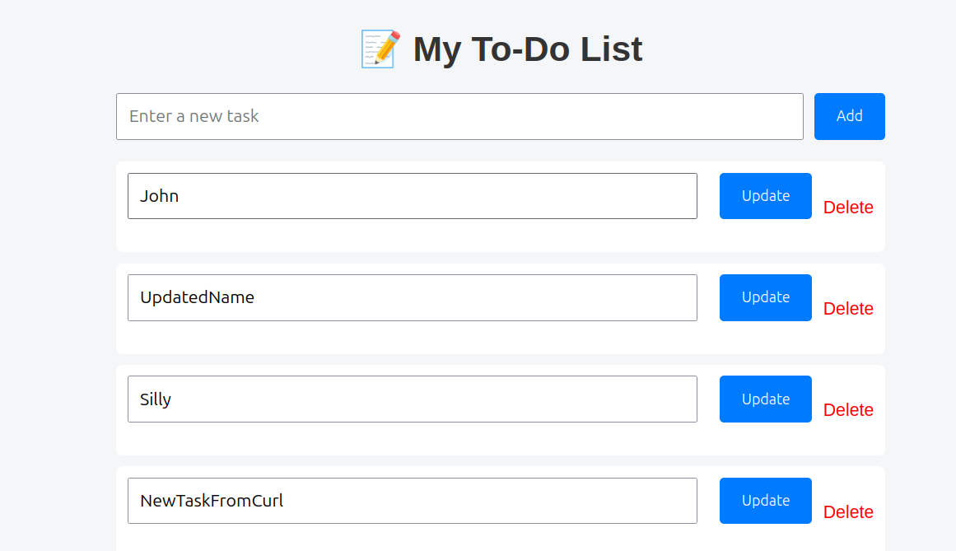
------------------------------------------------------------------
Delete Operation :

